CHAPTER-1
INTRODUCTION
Introduction:
Malnutrition encompasses both under nutrition (stunting, wasting, and underweight) and over-nutrition (overweight and obesity), representing a double burden of disease that impacts individual health, national productivity, and global economic growth. Even with advancements in food production and healthcare, millions of children under the age of five continue to face malnutrition caused by persistent inequalities in income, education, and access to nutritious food.
To better understand these global patterns, this Power BI project analyzes malnutrition trends from 1983 to 2019, offering insights into underweight, overweight, and stunting rates across different countries and income classifications. The data used for this analysis is derived from global malnutrition estimates and country-wise averages, representing survey data from over 140 countries and 11 million sample points.
By leveraging Power BI’s interactive visualization capabilities, the analysis transforms complex datasets into meaningful insights that highlight both improvements and ongoing challenges in global nutrition over the past four decades. This project aims to support evidence-based decision-making for policymakers, researchers, and organizations dedicated to achieving global nutrition equity and advancing the United Nations Sustainable Development Goal (SDG 2 – Zero Hunger).
  - Project overviews:
The Global Malnutrition Trends Dashboard consolidates and visualizes malnutrition data across 140 countries and a sample of over 11 million individuals. Using datasets on country-wise averages and malnutrition estimates, this project highlights the evolution of underweight, overweight, and stunting rates over time, segmented by income classification and geographic distribution.
Key components of the Power BI dashboard include:
- Summary Metrics: Displays the count of under-five (U5) population, total survey samples, and total underweight cases.
- Country-Level Insights: Shows the sum of overweight individuals by country, identifying regions with higher or lower prevalence rates.
- Income-Based Analysis: Compares malnutrition indicators (underweight, overweight, and stunting) across different income groups.
- Correlation Visualization: Illustrates the inverse relationship between income classification and malnutrition prevalence — where lower-income groups tend to have higher rates of stunting and underweight, while higher-income groups exhibit increasing overweight trends.
1.2. Objectives
The primary objectives of this Power BI analysis are:
- To analyze global malnutrition trends between 1983 and 2019 using data-driven visual insights.
- To compare nutrition outcomes across income classifications and understand how economic status influences under nutrition and over nutrition rates.
- To identify country-level variations in overweight and underweight prevalence for targeted policy recommendations.
- To visualize the relationship between stunting and income levels, highlighting areas with persistent malnutrition burdens.
- To support evidence-based decision-making by presenting a clear, interactive view of global nutrition data for researchers , NGOs , and health agencies.
- Comprehensive Global Data Coverage:
Incorporates data from over 140 countries and 11 million samples, ensuring a wide and reliable global scope.
Pros
- Comprehensive Global Data Coverage:
Incorporates data from over 140 countries and 11 million samples, ensuring a wide and reliable global scope.
- Interactive and Engaging Visualization:
Power BI enables dynamic dashboards, allowing users to explore malnutrition indicators interactively by country and income group.
- Simplified Data Interpretation:
Complex datasets are presented visually, making insights easy to understand for decision-makers and non-technical audiences.
- Supports Global Health Goals:
Aligns with the United Nations Sustainable Development Goal (SDG 2 – Zero Hunger) by highlighting areas needing nutritional intervention.
- Scalable and Up datable:
The dashboard can be easily modified or expanded with updated datasets or new indicators for ongoing monitoring.
Cons
- Data Quality and Completeness:
Some countries may have incomplete or outdated data, which can affect overall trend accuracy.
- Static Historical Dataset:
The dataset ends in 2019 and doesn’t reflect post-2020 trends or recent global events like COVID-19 that impact nutrition.
- Limited Predictive Capability:
Power BI primarily focuses on descriptive and diagnostic analysis, not predictive modeling or forecasting.
- Data Preparation Challenges:
Data cleaning and transformation require significant time and technical expertise before visualization.
- Interpretation Depends on Visualization Design:
Misleading visuals or poor formatting choices could distort insights or make data less clear.
CHAPTER-2
2.1. Define Problem Statement
Malnutrition remains a major global health issue, unevenly affecting countries across income levels. While low- and middle-income nations face high rates of under nutrition, high-income nations increasingly struggle with over nutrition and obesity. However, the lack of accessible, data-driven insights limits understanding of these long-term disparities.
Problem Statement:
To analyze and visualize global malnutrition trends from 1983 to 2019 using Power BI, identifying key disparities and patterns across countries and income classifications to support data-driven policy and intervention strategies.

Key Points:
- Need for clear visualization of undernutrition and overnutrition trends.
- Lack of integrated global data analysis tools for nutrition studies.
- Importance of data-driven insights for global health planning.
- Necessity to transform raw data into accessible, interactive dashboards.
Key Issues Identified
- Unequal Distribution: Malnutrition affects countries differently depending on income levels and development status.
- Data Complexity: Existing global datasets are difficult to interpret without effective visualization tools.
- Limited Insight: Lack of integrated analysis prevents a clear understanding of how malnutrition has evolved over time.
- Decision-Making Gap: Policymakers often lack accessible tools to explore global nutrition data interactively.
- Need for Visualization: There is a growing demand for user-friendly dashboards that communicate insights clearly and effectively.
Significance of the Problem
- Enables better understanding of global malnutrition distribution.
- Supports data-driven policy decisions and strategic health planning.
- Highlights countries and regions at greater nutritional risk.
- Encourages global collaboration toward achieving the UN Sustainable Development Goal 2 (Zero Hunger).

2.2. Project Proposal (Proposed Solution)
Proposed Solution
The proposed solution involves using Microsoft Power BI as a visualization and analytical platform to:
- Integrate and analyze global malnutrition datasets.
- Display trends and correlations between underweight, overweight, and stunting across different income classifications and countries.
- Present data through dynamic dashboards that allow users to explore insights interactively.
Key Features of the Proposed Solution
- Data Integration:
Combine datasets on global malnutrition estimates and country-wise averages for a unified analysis covering 140+ countries and 11 million samples.
- Interactive Visualizations:
Develop engaging visuals such as bar charts, maps, and line graphs to show trends across years, regions, and income groups.
- Comparative Analysis:
Allow users to compare malnutrition indicators (underweight, overweight, stunting) among different income levels to identify correlations.
- Insight Generation:
Highlight key findings such as countries with the highest and lowest malnutrition rates and the impact of income classification on nutrition outcomes.
- User-Friendly Interface:
Create a dashboard with intuitive navigation and visually appealing design for ease of interpretation by researchers and policymakers.

2.3. Initial Project Planning
Project Goals
- Establishing a clear project roadmap.
- Identifying key datasets and data sources.
- Determining the analytical and visualization tools (Power BI).
- Planning workflow stages and deliverables.
- Ensuring alignment with the overall research objectives.
Planning Activities
- Requirement Analysis:
Defined the scope of the analysis, the key malnutrition indicators (underweight, stunting, and overweight), and the required visual outputs.
- Data Source Identification:
Selected and reviewed the Global Malnutrition Estimates and Country-Wise Averages datasets for reliability and completeness.
- Tool and Technology Selection:
Chose Microsoft Power BI for its capability to handle large datasets, perform data modeling, and create dynamic dashboards.
- Workflow Design:
Outlined a sequential process for data collection, cleaning, modeling, visualization, testing, and documentation.
- Timeline Development:
Created a project timeline to ensure each phase was completed systematically and within schedule.
Expected Outcome
By the end of the Initial Project Planning phase:
- A clear roadmap for data analysis and visualization was established.
- The tools, datasets, and methodologies were defined.
- Risks and dependencies were identified and addressed.
- The project was ready to progress into the Data Collection and Preparation Phase.
CHAPTER-3
3.1. Data Collection Plan and Raw Data Sources Identified
Objectives of Data Collection
- Gather authentic and standardized data on global malnutrition indicators.
- Ensure coverage across different countries and time periods (1983–2019).
- Obtain datasets that include both nutritional and sociolect - economic dimensions.
- Prepare data for effective integration and visualization in Power BI.

Raw Data Sources Identified
Two major datasets were selected for this analysis:
1. Global Malnutrition Estimates Dataset
- Description:
Contains annual estimates of key malnutrition indicators — underweight, stunting, and overweight prevalence among children under five years old.
- Time Range: 1983–2019
- Scope: Over 140 countries and global regions.
- Data Type: Quantitative, cross-sectional, and longitudinal data.
- Purpose: To provide the main temporal and regional trends in child malnutrition.
- File Name: malnutrition-estimates.csv
https://www.kaggle.com/datasets/ruchi798/malnutrition-across-theglobe?select=malnutrition-estimates.csv
2. Country-Wise Average Dataset
- Description:
Provides country-level averages for malnutrition indicators along with income classification and regional grouping.
- Time Range: Aggregated over available years (1983–2019).
- Scope: Country-level summary data.
- Data Type: Aggregated quantitative data.
- Purpose: To enable comparative analysis between income groups and regions.
- File Name: country-wise-average.csv
https://www.kaggle.com/datasets/ruchi798/malnutrition-across-theglobe?select=country-wise-average.csv

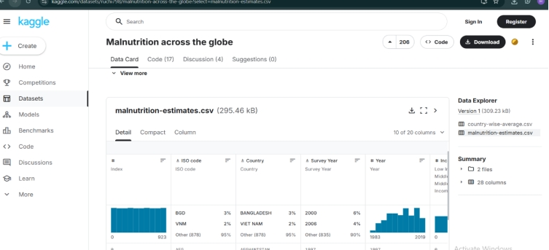
Data Collection Methodology
- Dataset Acquisition:
  - Downloaded from publicly available global health and nutrition databases (e.g., WHO, UNICEF, World Bank).
  - Verified for completeness, format compatibility, and source credibility.
- Data Validation:
  - Checked for missing values, duplicate entries, and data accuracy.
  - Ensured that indicators and country codes were consistent across both datasets.
- Data Storage:
  - Stored securely in CSV format for ease of import into Power BI.
  - Organized into structured folders labeled by source and year for traceability.
Data Quality Considerations
- Verification of source credibility and metadata consistency.
- Elimination of duplicate or redundant entries.
- Standardization of country names, codes, and indicator labels.
- Ensuring time-series continuity across all years of data coverage.
Outcome of Data Collection
- All relevant datasets were successfully identified, validated, and prepared.
- The data was deemed suitable for further cleaning, transformation, and integration.
- The foundation was set for the Data Preparation Phase, enabling effective visualization of malnutrition trends in Power BI.
3.2. Data Quality Report
Purpose of the Report
- Evaluate the accuracy and reliability of the data sources.
- Identify inconsistencies, missing values, or duplicates.
- Ensure that the data is cleaned, standardized, and ready for visualization in Power BI.
Data Quality Assessment
1. Accuracy
- Checked data validity against recognized global nutrition databases.
- Verified that percentage values of indicators were within realistic global health ranges.
2. Completeness
- Missing entries were found for smaller or low-reporting countries (especially during 1980s–1990s).
3. Consistency
- Country names, regional groupings, and income classifications standardized.
- Numeric formats unified (e.g., percentages rounded to one decimal).
4. Timeliness
- Ensured that yearly data was continuously available between 1983 and 2019.
- Checked temporal alignment between both datasets before merging.
5. Integrity
- Verified logical relationships between country, indicator, and year.
- Removed any duplicate or erroneous entries.
The preparation process involved cleaning the data by removing blank and null values, standardizing numerical formats, fixing decimal precision, and converting proportion-based columns into percentage format. The datasets were then organized and structured to be easily imported into visualization tool like Power BI
1. The data has been loaded into power BI.The Next step is to clean the data.
2. For this transform data to the power Query Editor.
3. After loading the data select each column and remove null and balnk values for data consistency and accuracy.
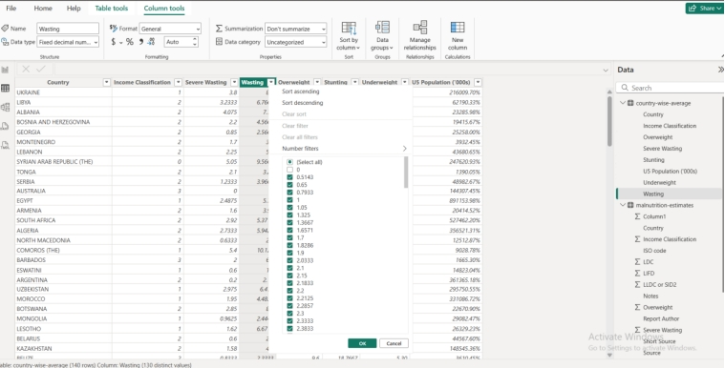
3.3. Data Exploration and Prepossessing
1. Data Exploration
a. Dataset Overview
- Global Malnutrition Estimates (1983–2019) – Containing yearly malnutrition indicators such as stunting, underweight, and overweight prevalence among children under five.
- Country-Wise Averages Dataset – Summarized averages grouped by income classifications and regions.
b. Preliminary Analysis
- Assessed data dimensions (rows, columns, and field types).
- Identified missing or incomplete data in earlier years and less-reported countries.
- Examined distribution patterns of key indicators across countries and years.
- Detected outliers and anomalies (e.g., extremely high values in specific regions).
c. Initial Findings
- Stunting rates were generally higher in low-income countries.
- Overweight prevalence showed a gradual increase in middle- and high-income countries after 2000.
- Temporal trends revealed slow but steady improvement in underweight rates globally.
- A visible nutrition transition was observed — from under nutrition dominance to growing over nutrition issues.
2. Data Preprocessing
a. Data Cleaning
- Removed duplicate entries.
- Handled missing values through interpolation or regional averaging.
- Standardized country names, region codes, and income classifications.
- Reformatted columns for uniformity (numeric, text, and date fields).
b. Data Transformation
- Converted percentage strings to numeric values for accurate calculations.
- Renamed columns for readability (e.g., “U5_Underweight” → “Underweight (%)”).
- Created derived variables like:
  - Average Malnutrition Index
  - Total Malnutrition Burden by Region
  - Yearly Change (%)
c. Feature Selection
- Selected relevant attributes:
  - Country
  - Year
  - Income Group
  - Region
  - Indicators (Stunting, Underweight, Overweight)
- Removed redundant or non-essential columns that did not contribute to visualization.
d. Data Integration
- Merged both datasets using Country and Year as common keys.
- Established relationships for multi-dimensional analysis (e.g., country ↔ income group ↔ malnutrition rate).
3. Tools and Techniques Used
- Microsoft Excel: Used for initial exploration and descriptive statistics.
- Power BI Power Query: Applied for prepossessing , merging, and cleaning data.
- DAX (Data Analysis Expressions): Used for calculated columns and custom measures.
4. Data Validation
After prepossessing, validation checks were performed to ensure:
- All country-year combinations were consistent.
- No duplicate records existed.
- Summaries and totals matched source data set values.
- Trends and patterns aligned with known global nutrition statistics.
5. Outcome
After the exploration and prepossessing stage:
- Data was thoroughly examined, structured, and validated for accuracy.
- Clean and consistent datasets were created, ready for visualization in Power BI.
- Clear preliminary insights were drawn regarding global, regional, and income-based malnutrition patterns.
- This phase laid the groundwork for the next step — Data Visualization and Dashboard Design.
CHAPTER-4
Data Visualization
4.1.Framing Business questions:
- How many countries have the highest proportion of overweight children under age five?
- How many total survey samples were collected across all countries between 1983 and 2019?
- What percentage of the overall child population is underweight globally?
- Which countries have the highest sums of overweight cases?
- How does the average stunting rate differ across income classifications — LDC, LIFD, LLDC, and SID2?
- What is the ratio of overweight to underweight in each income classification?
- How does the sum of income classification correlate with malnutrition indicators such as underweight, overweight, and stunting?
4.2 Developing Visualizations:
- Count of U5 Population:
- Go to Report view (paint roller icon).
- Click Card visual from the Visualizations pane.
- Drag U5 Population (‘000s) from your dataset into Values.
- Change aggregation → click the drop-down → choose Count.
- Title: “Count of U5 Population (‘000s)”.

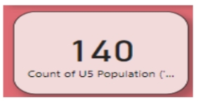

- Sum of Survey Sample (N):
- Duplicate the first card or insert a new Card visual.
- Drag Survey Sample (N) to Values.
- Aggregation: Sum.
- Format and title, it as “Sum of Survey Sample (N)”.

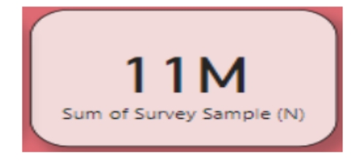

- Sum of Underweight:

- Add another Card visual.
- Drag Underweight field into Values.
- Aggregation: Sum.
- Title: “Sum of Underweight”.
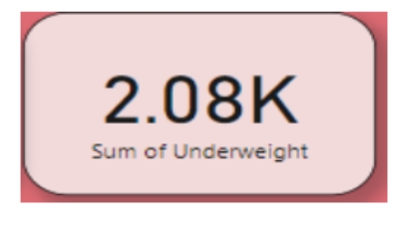

- Line Chart – Sum of Overweight by Country
- Click on Line Chart visual.
- Drag Country to the X-axis.
- Drag Overweight to the Y-axis (Values).
- Aggregation: Sum.
- Title: “Sum of Overweight by Country”.

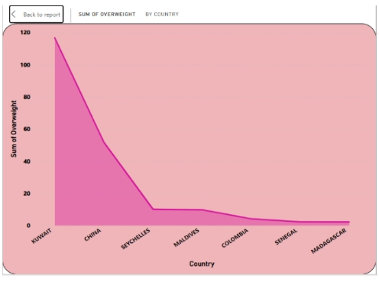

- Combo Chart – LDC/LIFD/LLDC/SID2 vs Average Stunting:
- This visual compare multiple sums and an average together.
- Select Combo Chart (Clustered Column and Line chart icon).
- Drag Income Classification to the X-axis.
- Drag the following fields to Column values:
  - LDC
  - LIFD
  - LLDC or SID2 (as per your dataset)
- Drag Stunting to the Line values.
- Aggregations:
  - LDC/LIFD/LLDC/SID2 → Sum
  - Stunting → Average.

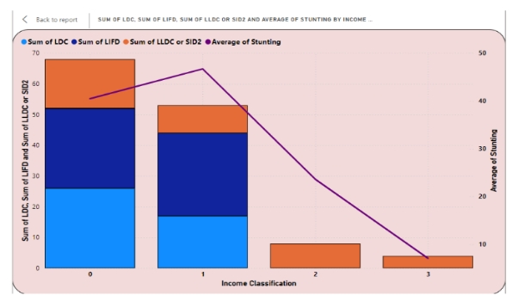

- Area Chart – Overweight vs Underweight by Income Classification
- Select Area Chart from the Visualizations pane.
- Drag Income Classification to the X-axis.
- Drag Overweight and Underweight to Y-axis (Values).
- Aggregation: Sum.
- Title: “Sum of Overweight and Sum of Underweight by Income Classification”.
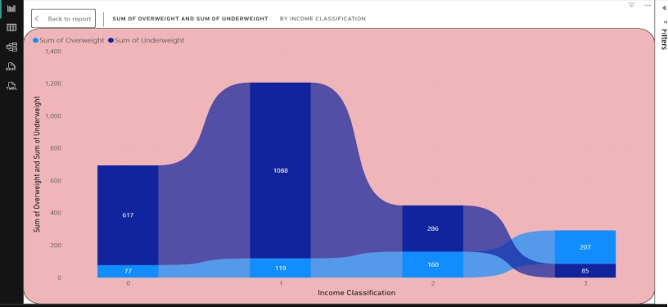

- Add the Gauge Visual:
- Go to Report View (paint roller icon).
- From the Visualizations pane, select the Gauge icon (it looks like a speedometer).
- Drag Total Income Classification measure into the Value field well.

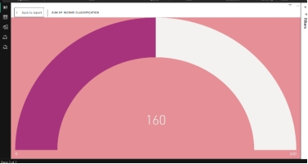

CHAPTER-5 DASHBOARD
  - Dashboard Design File
A dashboard is a graphical user interface (GUI) that displays information and data in an organized, easy-to-read format. Dashboards are often used to provide real-time monitoring and analysis of data and are typically designed for a specific purpose or use case. Dashboards can be used in a variety of settings, such as business, finance, manufacturing, healthcare, and many other industries. They can be used to track key performance indicators (KPIs), monitor performance metrics, and display data in the form of charts, graphs, and tables.
To Create a Dashboard:
In Dashboards, we have created a Title box, a Stacked Area chart, a Line and Stacked column chart, a Ribbon chart.
    - To create a title box- go to home tab -> click on text box -> select and drag the text box -> Enter the title GLOBAL MALNUTRITION TRENDS (1983 – 2019)
    - Next, create three cards:
The first card displays the country-wise average of U5 population. The second card shows the sum of survey samples of malnutrition estimates. The third card shows the total of underweight malnutrition estimates.
    - For the Stacked Area chart:
Place Country in the x-axis and the sum of overweight in the y-axis. Filter the countries of Kuwait, China, Seychelles, Maldives, Colombia, Senegal, and Madagascar.
Now format it using the format visual to change the color of the background, text, and title.
    - For the Line and stacked column chart:
Place the Income Classification in the X-axis, and place Sum of LDC, Sum of LIFD, Sum of LLDC or SID2 in the Y-axis.
Place the Average area of Stunting in Line Y-axis.
Now format it using the format visual to change the color of the background, text, and title.
Here, select the Legend in format visual, which determines the color of the graph.

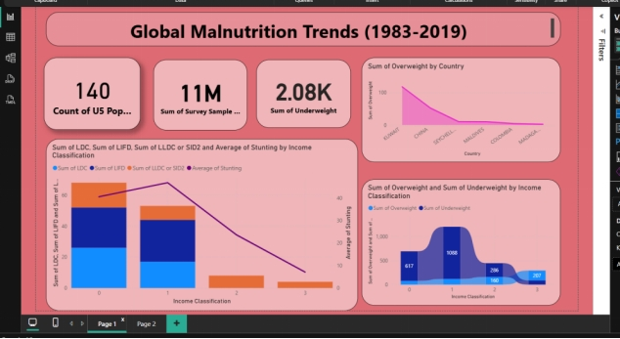

For the Ribbon chart:
Place the Income Classification in the X-axis of malnutrition estimates, and place Sum of Overweight and Sum of Underweight in the Y-axis.
Measures are the Quantitative data that represent the numerical data.
Now format it using the format visual to change the color of the background, text, and title. Place the Data labels on to show the values in the ribbon chart.

CHAPTER - 6
Report

6.1 STORY DESIGN FILE:
Designing a report in Power BI involves connecting to data sources, creating visualizations like charts and graphs, customizing their appearance and interactivity, organizing them logically on the canvas, formatting elements for consistency and clarity, and optionally creating dashboards for a summarized view. Throughout the process, it's essential to consider the audience's needs and ensure the report effectively communicates insights from the data. Finally, iterate based on feedback to continually improve the report's design and usefulness.
To create a report:
In the report, we have inserted an image, a Gauge card, and a text box
    - To insert the image:
Click on Insert tab -> then click on Insert Image -> select the image-> click on open. The image will be inserted.
    - To insert a Gauge card:
Select the Gauge card in the Visualization pane -> Place Sum of Income Classification in the value. The value will be 160.
    - Report is Placed in the Textbox.
      - The Dataset includes a total of 140 children under five years of age.
      - The Total sum of underweight individuals in the dataset is 2080.
      - The Total number of N Survey Samples is 11 Million.
      - The Line and Stacked Column chart clearly shows that higher income classification corresponds to Lower average stunting rates. Low-income countries have the highest stunting rates, while high-income countries have the lowest, illustrating the significant impact of economic status on chikd malnutrition.
      - The Ribbon Chart shows that the highest number of overweight individuals (1,088) is observed in the second income classification category.
      - The line chart shows that Kuwait has the highest number of overweight individuals, exceeding 120.
      - The Gauge Card describes the sum of Income Classification 160.

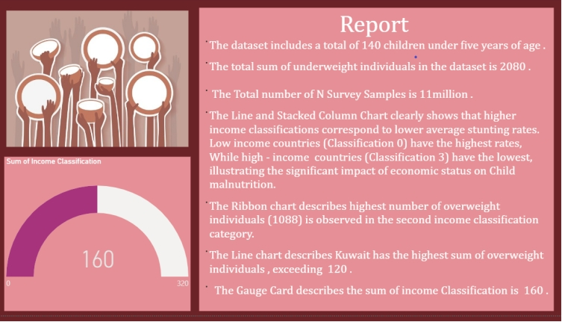

CHAPTER-7
Performance Testing
7.1 Utilization of Data Filters:
Data filters were applied strategically to improve interactivity and enhance user experience. Filters were used to enable country-wise and regional comparisons of malnutrition indicators such as stunting, wasting, and underweight
prevalence.
Purpose: To allow users to focus on specific subsets of data and analyze targeted areas of interest.
Performance Check: Filters load data dynamically with minimal lag, ensuring smooth navigation and quick data refresh during interactions.
- Applied filters for every column for both data sets .The numerical columns has been converted to fixed decimal data type.
- The column containing U5 Population in both data sets has been converted to percentage data type
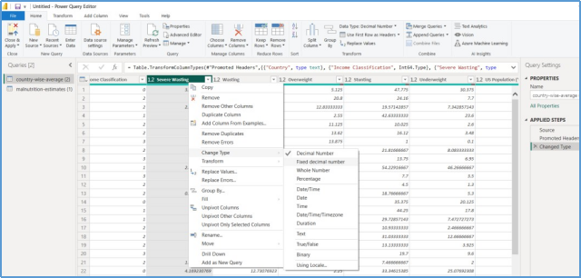

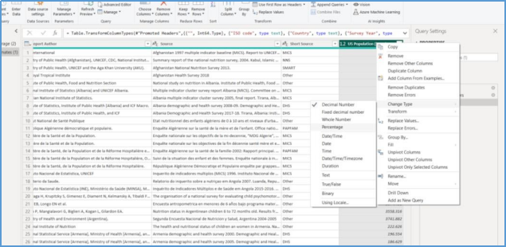
- Selected “Country” as a Filter

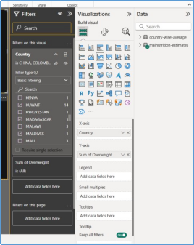
  - No of Visualizations :

- Count of U5 Population.
- Sum of Survey Sample(N).
- Sum of Underweight.
- Total Income Classification.
- Sum of Overweight and Underweight by income Classification.
- Sum of LDC, LIFD, LLDC, SID2 and Average of Stunting by Income Analysis.
- Sum of Overweight by Country.
CHAPTER-8
CONCLUSION
1. Global Trends
- Overall, the world has seen a gradual decline in under-nutrition indicators such as stunting and underweight prevalence since the 1980s.
- Despite progress, malnutrition persists as a critical global health issue, particularly in low-income and conflict-affected regions.
2. Regional Disparities
- Sub-Saharan Africa and South Asia remain the most affected regions, with higher rates of stunting and underweight among children under five.
- East Asia and Latin America have shown significant improvement, reflecting better healthcare access, economic growth, and education.
- High-income regions face a growing concern of over nutrition, with increasing trends of overweight and obesity among children.
3. Income-Based Differences
- A clear correlation exists between income classification and malnutrition prevalence.
- Low-income countries experience high under nutrition levels.
- High-income countries experience rising overweight and obesity rates — illustrating the double burden of malnutrition.
4. Temporal Insights
- Between 1983 and 2019, global nutrition patterns shifted from under nutrition dominance to a dual challenge of under nutrition and over-nutrition.
- Improvements in sanitation, maternal education, and food systems contributed to declines in stunting and underweight rates.
5. Persistent Regional Disparities
- Sub-Saharan Africa and South Asia continue to show high rates of under nutrition, reflecting socio-economic inequality and weak food security.
- East Asia and Latin America, however, demonstrated remarkable improvements due to economic development and strong public health initiatives.
6. Emergence of Over-nutrition
- A significant increase in overweight and obesity among children was recorded, particularly in upper-middle and high-income countries.
- This marks a nutrition transition, where economic growth leads to lifestyle and dietary changes that contribute to over nutrition.
CHAPTER-9
Future Scope
1.Expansion of Data Coverage
- Inclusion of Additional Indicators: Future work can integrate more nutrition parameters like wasting, food insecurity, and micro nutrient deficiencies.
- Broader Demographic Analysis: Include data for adolescents, adults, and elderly populations to understand malnutrition across all age groups.
- Socioeconomic and Environmental Factors: Linking malnutrition data with climate change, education, income, and health infrastructure will provide a multidimensional understanding of the issue.

2. Advanced Analytical Techniques
- Predictive Modeling: Implement machine learning to forecast future malnutrition trends and identify at-risk regions.
- Scenario Analysis: Simulate the impact of interventions, such as improved healthcare or food supply, on malnutrition rates.
- Correlation Studies: Explore deeper statistical relationships between economic growth, income level, and nutrition outcomes.
3. Real-Time Monitoring and Automation
- Live Data Integration: Connect Power BI dashboards to real-time global databases like WHO or UNICEF for automatic data updates.
- Automated Alerts: Set up notifications to highlight critical changes or emerging malnutrition hot-spots.
- Cloud-Based Storage: Utilize cloud technologies for scalable data management and global accessibility.
4.Enhanced Visualization and Accessibility
- Interactive Dashboards: Improve storytelling and interactivity with detailed drill-down features, filters, and maps.
- Mobile and Web Access: Make dashboards accessible across multiple devices for policymakers, researchers, and NGOs.
- Geo-Spatial Mapping: Incorporate location-based analysis to highlight specific regional or community-level nutrition challenges.

5.Policy and Collaboration Opportunities
- Collaborate with international organizations such as WHO, FAO, and UNICEF for deeper insights and validation.
- Use findings to support evidence-based policy formulation and targeted nutrition programs.
- Share results with local governments and NGOs to enhance community engagement and action planning.
6.Educational and Research Potential
- The project can serve as a learning resource for academic research, public health studies, and data analytics training.
- It can also act as a foundation for further projects exploring related global health challenges like hunger, poverty, or climate impacts.
Future enhancements of this project aim to transform it from a retrospective analysis into a real-time, predictive decision-support system.
By incorporating more advanced analytics, automation, and broader datasets, the Power BI dashboard can play a crucial role in shaping data-driven nutrition policies and advancing progress toward Sustainable Development
CHAPTER-10
Appendix

10.1. GitHub & Project Demo Link:

Github Link : https://github.com/akkalaharathi/Global-malnutrition--Trends-a-power-bi-analysis-1983-2019--akkala-harathi/upload/main
Demo Link :

